Design Overview for Sky Jump Adventure

Name: Tran Quang Huy
Student ID: 106212636

Summary of Program

This program is a simple 2D platform game inspired by the mechanics of Jump King. The player controls a character whose main goal is to jump from one platform to another and climb as high as possible. The challenge of the game comes from the precise timing and power required for each jump. If the player misses a platform, the character may fall to a lower level and must try again.

The game will include multiple platforms placed at different heights. The player will use keyboard controls to charge a jump and release to jump upward. As the player progresses higher, the platforms will become more difficult to reach, requiring more accurate timing. The game will track the player’s height or score and display it on the screen.

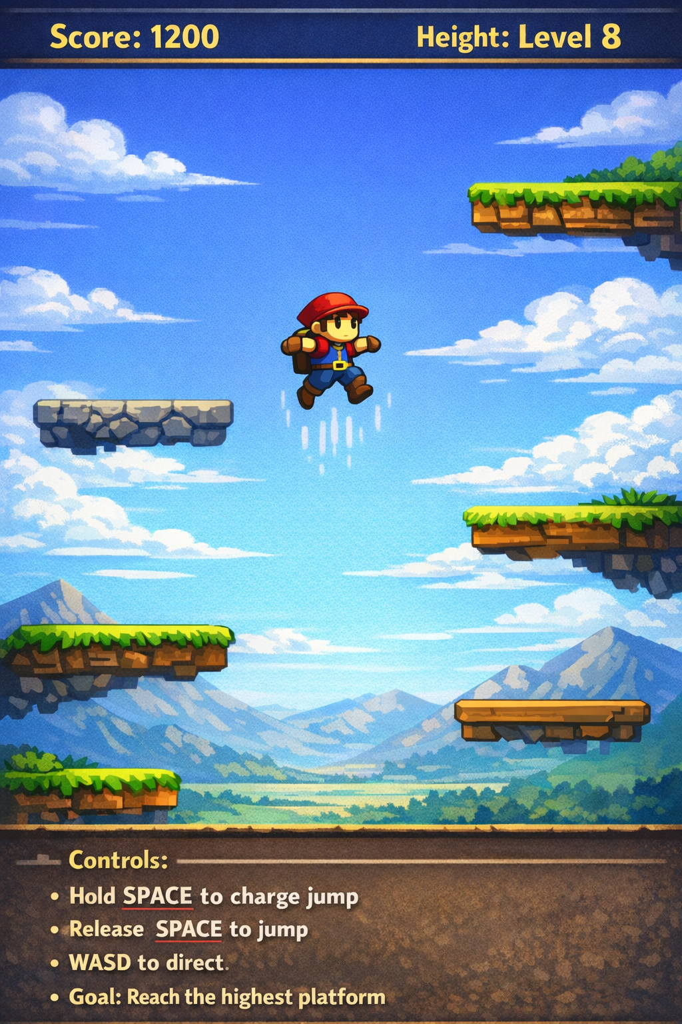

Required Data Types

Describe each of the classes and dictionaries (or enumerations) you will create using the following table (one per record).
Table 1: Character details

Field Name | Type | Notes
x_position | int | Horizontal position of player
y_position | int | Vertical position of player
jump_power | int | Strength of jump
is_jumping | bool | Indicates if player is jumping
velocity_y | float | Vertical movement speed
x_position | int | Horizontal position of player

Table 2: platform details
Field name | Type | Notes
x_position | int | Horizontal position of platform
y_position | int | Vertical position of platform
width | int | Width of platform
height | int | Height of platform

Table 3: Gamestate Dictionary
Value | Notes
score | Current player score
level | Current level or height
game_over | Boolean to check if player lost

Overview of Program Structure

-main()

Controls the overall flow of the game, including starting the game loop and calling other functions.

-create_player()

Creates and initializes the player character.

-generate_platforms()

Creates a list of platforms at different heights.

-handle_input()

Reads keyboard input from the player (charging and releasing jumps).

-update_player()

Updates the player’s position based on gravity and jump power.

-check_collision()

Checks if the player lands on a platform.

-draw_game()

Draws the player, platforms, and score on the screen.

-update_score()

Updates the score depending on how high the player climbs.

-game_loop()

Runs continuously to update the game state and render graphics.
